.A HAND UP 4 VETS AUCTION LEFTOVERS 4 SALE
100% of purchase supports homeless and disabled veterans.
Please email your offer to JWV for vets@gmail.com or text to 858-245-0829
Mastercard, Visa, American Express, Discover, Pay Pall and Zelle will all be accepted for payment

64 Tee For Two Ironwood Country Club; Round of Golf for Two with Cart $150 $ 75
6 Tequila Tasting Private Agave Spirits Tasting for 8-10 friends with renowned Tequila 400 200
Specialist. Event can contain educational and aspects historical as
As well as an enhanced tasting experience g six Agave spirits .

20 4 A Baby Boy A Diaper bag filled with 14 outfits and 30 useful items for the parents 140 70 of a new baby boy

21 4 A Baby Girl A Diaper bag filled with 14 outfits and 30 useful items for the parents 140 70
of a new baby girl.

26 Film Festival Enjoy 30+ great films in the comfort of your own home with this household $225 100.
Pass to the 26th annual Greater Phoenix Film Festival. (Feb. 10-28, 1922)

71 Team Signed An official NBA Basketball signed by every member of the Boston Celtics 300 145
Basketball Basketball Team.

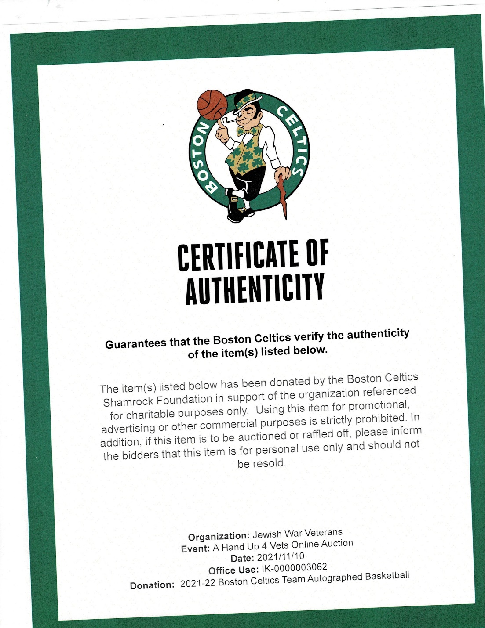

23 Lose Weight or 4 virtual sessions with renown hypnotherapist Cheryl Elman will help you 595 295
Stop Smoking lose those unwanted pounds or stop smoking.

72 Team Signed An official NBA Basketball signed by every member of the Miami Heat 300 145
Basketball Team.

7 Get More Room Three 4 hour sessions with Kim, owner of Joyful Downsizing to help you
From Your Space organize your home, office or garage, (Chandler,Tempe, Gilbert &Scottsdale only) 300 100

24 Ryobi Circular Saw Great for either a Do it Your selfer or Handy Man. Includes:
a 7-1/4 inch Blade, Blade Wrench and 6 ft. Cord, . Backed by 55.00 35.00 Ryobi’s 3 year Limited Warranty

39 Have a delicious lunch at Pier 54 on the lakeshore in Tempe where author, Stephanie Silverman 175 85
Hauser will give you an autographed copy of her book, Plan B. In the book Stephanie tells us how she
and her husband sold their marketing business, their home and all their belongings to live on a catamaran
sailboat and attempt to sail around the world.. Find out how they survived a two-year trip her husband fell
off the boat the FIRST day. Their journey was filled with storms, sharks, and a realistic fear of pirates, lived
off the sea, and ultimately got hit by lightning In this hysterical recollection from her travel diaries, Stephanie
experiences frustration and fear on a roller coaster mixed with joy and bravery while learning about herself,
her husband and her tolerance for a latte less lifestyle.

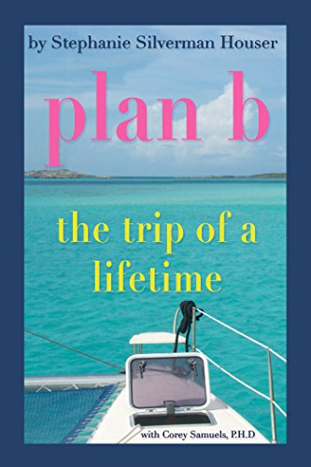

6. Hollywood History "Father's Little Dividend" one sheet movie poster by Unknown, 1951 Unsigned Offset Lithograph. Paper size is 41.25 x 27 inches, with an image size of 41.25 x 27 inches. The Offset Lithograph is #51 from an edition of 139 It is linen backed . Additional details: First edition movie poster starring Spencer Tracy, Joan Bennett and Elizabeth Taylor titled "Father's Little Dividend".

